UNIX

Foundation Exercises

Module 04 - Wildcards & Quotation

© FDM Group Ltd 2022. All Rights Reserved.

Any unauthorised reproduction or distribution in part  
or in whole will constitute an infringement of copyright.

Copy the directory **/student_files/day2/courseware/mod4Exercise** to your home directory, then **cd** into it.

cp -r /student_files/day2/courseware/mod4Exercise ~

Use **ls** to display the files:

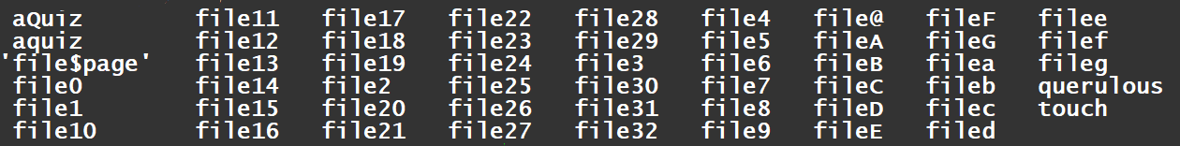

**Perform the following tasks (using a single command line for each)**

* + - 1. Use the **ls** command with appropriate wildcards to show only the following:

1. Filenames containing a lower case "q" : ls *[q]*
2. Filenames containing "q" - upper case or lower case: ls *[q,Q]*
3. Filenames containing "q" (lower case) at the beginning: ls q*
4. Filenames ending with a digit: ls *[[:digit:]]*
5. Filenames ending in a capital letter: ls *[[:upper:]]*
6. Filenames not ending in a capital letter: ls *[[:alnum:]]*
7. Filenames ending in a digit or a capital letter: ls *[[:digit:],[:upper:]]*
8. Filenames ending in "a" or "e": ls *[a,e]
9. Filenames ending with two digits (eg file10 but not file0 or file9): ls *[[:digit:]][[:digit:]]*
10. Filenames with one digit but not two (e.g file0 or file9 but not file10): ls file[[:digit:]]
11. Filenames containing a "$" sign (beginning, middle or end): ls *[$]*
12. Filenames with only 1 or 2 digit: ls file[0-9] file[0-9][0-9]
13. Create a variable called **username** and assign your full name to it - e.g "John Smith". **echo** it to be sure it worked.:
    1. username=(John Smith)
    2. echo ${username[*]} or echo $username
14. Using **echo**, display   
    **My name is 'Michael Caine'** : echo "My name is 'Michael Caine'"  
    - you should show the single quotes.
15. Using command substitution and the **pwd** command, echo out the string:  
    **The current directory is <*currentDirectory***>  
    where ***<currentDirectory>*** is your directory location (whatever that may be).
    1. dir=$(pwd)
    2. echo "The current directory is ${dir}"
16. Using command substitution and the **pwd** command, echo out the string:  
    **The current directory is** *<tab>* **currentDirectory**  
    where *<tab>* is a tabstop.
    1. echo -e "The current directory is \n \t${dir} \n where \t is a tabstop"